Anupreet Gupta

Pruthvi Ranjan Reddy Pati

Trishul Gowda Ashok

Vinaya Rao Hejmady

|  |  |
| --- | --- |
| ANALYZING EMPLOYEE FEEDBACK | Abstract  Using Text Mining techniques to generate insights from the employee feedback data to help company become a better and employee-friendly workplace.  BANA 7047: Data Mining II |

**Background:**

In this project, we take a sneak-peek at how employees review their workplace, to get a general idea of what it is like to work in different companies. We then move on to provide inputs to companies on what is working in their favor and what is not. It is important for companies to ensure that employees look forward to going to work each day and are satisfied working for the company. Employee satisfaction leads to high employee retention rate and is also a great way to capture new talent.

Feedbacks taken directly from employees are a great way for the HR team to know what they are doing right and tap into possible areas of improvement. Good reviews from employees are rewarding and satisfying for the HR team, and also can be used to market the company as a good place to work at. On the other hand, constructive feedback can be used by the HR team to continuously identify and work on possible concerns employees might have.

**Objective:**

To analyze Company’s Employee Feedback to help them become a better workplace through the following objectives:

* What are the attributes that largely affect a company’s ratings, and to what extent do the choice of words describing these attributes affect the ratings?
* Have the companies worked on their areas of improvement through the years, or not? Have the companies maintained their positive attributes, or not?

**Data:**

This dataset contains over 67,000 employee reviews for Google, Amazon, Facebook, Netflix, Apple and Microsoft. The following columns are available in the data:

1. Index: Unique identifier for each employee review
2. Company: Name of the company for which feedback is provided
3. Location:
   1. For non-US countries, the location will include the country's name in parenthesis [Toronto, ON(Canada)].
   2. In the USA, the location will only include the city and state [Los Angeles, CA]
4. Date Posted: YYYY-MM-DD format date on which the review was posted
5. Job Title: The job title includes whether the reviewer is a 'Current' or 'Former' Employee
6. Summary: Short summary of feedback for the company
7. Pros: Positive feedback for the company
8. Cons: Negative feedback for the company
9. Advice to Management: Areas of improvement for the company
10. Overall Rating: On a scale of 1 to 5
11. Work/Life Balance Rating: On a scale of 1 to 5
12. Culture and Values Rating: On a scale of 1 to 5
13. Career Opportunities Rating: On a scale of 1 to 5
14. Comp & Benefits Rating: On a scale of 1 to 5
15. Senior Management Rating: On a scale of 1 to 5
16. Helpful Review Count: A count of the number of people who found the review helpful
17. Link to Review: A direct link to the page that contains the review, but likely that the link is outdated

**Data Cleaning and processing:**

**Import text**

**Split Text into words**

**Create Unigrams**

**Clean the words**

**Create Bi-grams**

**Steps involved:**

1. Import text as a string into the environment (R or Python)
2. Split the text into individual words, separating them at white space
3. Remove punctuations and special characters
4. Remove Numbers (depends on the use case)
5. Convert all into lowercase or uppercase
6. Trip front and rear whitespace for each word
7. Remove stopwords i.e. remove words that don’t carry any emotion and are common. For example, “a”, “an”, “the”, “he”, “she”, etc.
8. Based on the analysis, the frequency of Uni-grams or bi-grams is calculated
9. In general, Bi-grams capture more meaning than Uni-grams and are more useful to analyze the underlying context.

**Preliminary Analysis (EDA):**

The main focus here are the on variables summary, pros and cons. They contain the feedback provided by an employee in text format. Below tables helps us understand the amount of feedback that is available for the six companies under consideration. Amazon, Apple and Microsoft (AAM) have a considerable amount of feedbacks and hence would be the center of our text mining analysis throughout the course of this analysis.

|  |  |  |  |
| --- | --- | --- | --- |
| **Company** | **# Reviews** | **Avg Word Count Pros** | **Avg Word Count Cons** |
| **Amazon** | 26430 | 21 | 32 |
| **Apple** | 12950 | 21 | 31 |
| **Facebook** | 1590 | 39 | 32 |
| **Google** | 7819 | 19 | 24 |
| **Microsoft** | 17930 | 21 | 30 |
| **Netflix** | 810 | 31 | 58 |

Table 1. Word Count and Reviews Statistics

Average word count in a Pro feedback for a AAM is ~ 21, while for a Con feedback is ~ 31 i.e 50% more that Pro. Below graphs provides a deeper understanding when the average word count is split into the basis of overall rating (ranging from 1 to 5, with 5 being the best).

* There is only slight fluctuation ( 5 – 10 %) with respect to the mean in average word count for a Pro feedback.
* Deviation in average word count for a Con feedback ranges from ( 50 – 150 %), with the trend being negatively correlated i.e as the ratings goes down average word count increases significantly.

**The Hard Truth is, Employees are expressive about their concerns and negative reviews for the company while takes minimum effort while praising!**

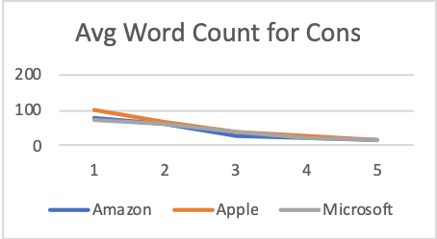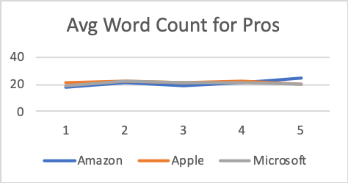

Figure 1. Ratings wise Avg Word Count for Pros & Cons

Analyzing feedbacks especially the words of the sentences, can provide a high-level sense of positive and negative aspects of the organization. The following graph illustrates the frequency of words from the positive feedbacks for Amazon.

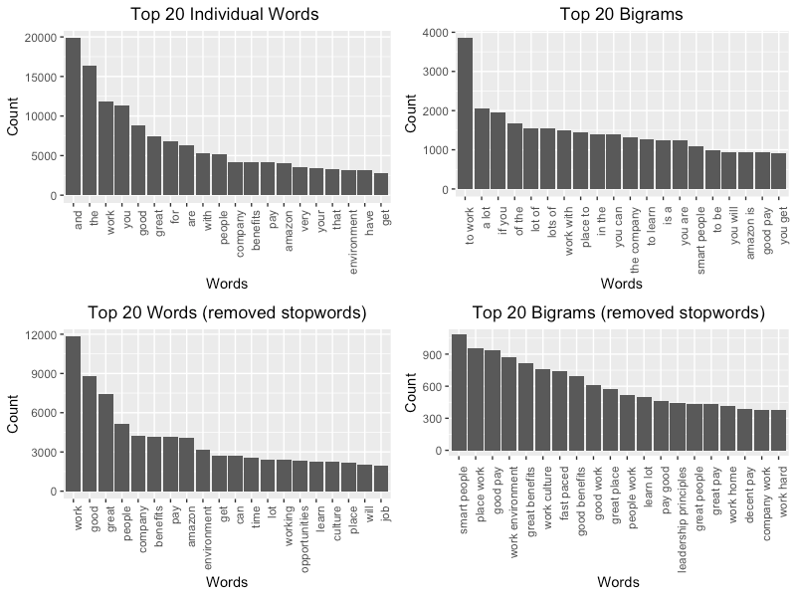

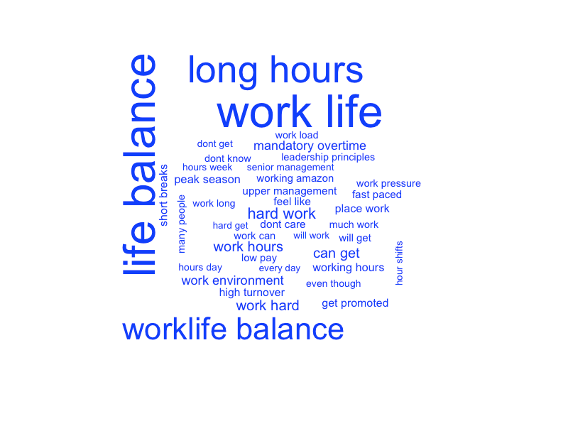In general Bi-grams i.e. taking 2 words at a time   
captures more meaning than individual words.   
The bottom right graph provides the most   
information on pros than the remaining.

* It can be inferred that **Pay – Benefits** and   
  **Culture – Environment** are the most   
  mentioned topics in the pros.

Considering the Bi Grams from Cons of Amazon   
feedbacks is shown on the right.

* The most illuminating concern are about   
  **Work Life balance, Working Hours   
  and Amount of work**

**The second hard truth is that the employees are being paid well at the expense of personal life and work stress**

**Year on Year Analysis:**

The goal of this analysis is to analyze the employee’s feedback (Pros and Cons) on a yearly basis to understand the core values and issues within an organization. Data for companies like Amazon, Apple and Microsoft are mined during the course of this analysis owing to the fact that the dataset comprised more than 80% from this three companies and undoubtedly, they are also amongst the top companies in their respective industry.

**Summarizing the steps involved:**

**Step 1: Importing Data**

Imported the dataset into the R environment by downloading it from [www.kaggle.com](http://www.kaggle.com) . A basic EDA and summary statistics functions were performed to understand the structure of dataset and plan on next steps.

**Step 2: Cleaning Data**

Columns of interest, which is the name of the company, date on which feedback is added to the glassdoor website, pros and cons columns of the feedback were filtered from the rest of the data set for Amazon, Apple and Microsoft.

Text mining cleaning involves:

* + - Checking for null values
    - Converting everything to lower case
    - Removing Non-Numbers or Non-alphabets
    - Removing extra white spaces
    - Removing Punctuations
    - Removing Numbers
    - Removing stop words

**Step 3: Text Mining and Visualization**

After the columns of interest has been mined and cleaned as per the requirement, they are split into different terms of n-gram (in this case bigram) and collated to form the Term Document Matrix, where in the frequency of each terms is measured. The frequency counts help to identify most occurring terms in the given texts.

Pros and Cons columns for each company is analyzed from year 2014 to 2018. The first challenge that occurred after having visualized these graphs were the need to redefine the stopwords dictionary.

For example, a combination of words like “worklife balance”, “work life”, “life balance” etc basically all pointing towards the miserable work-life balance for the employees.

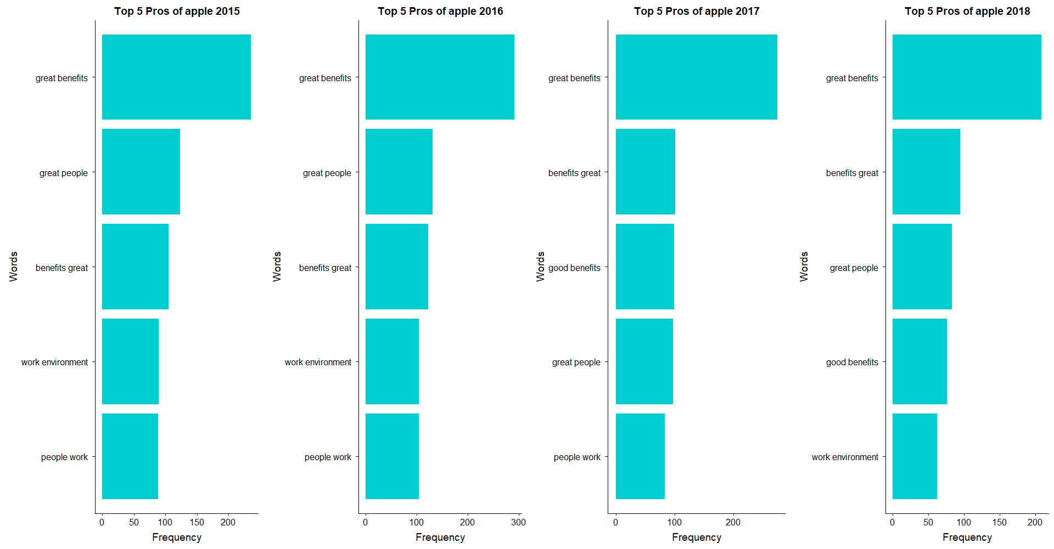

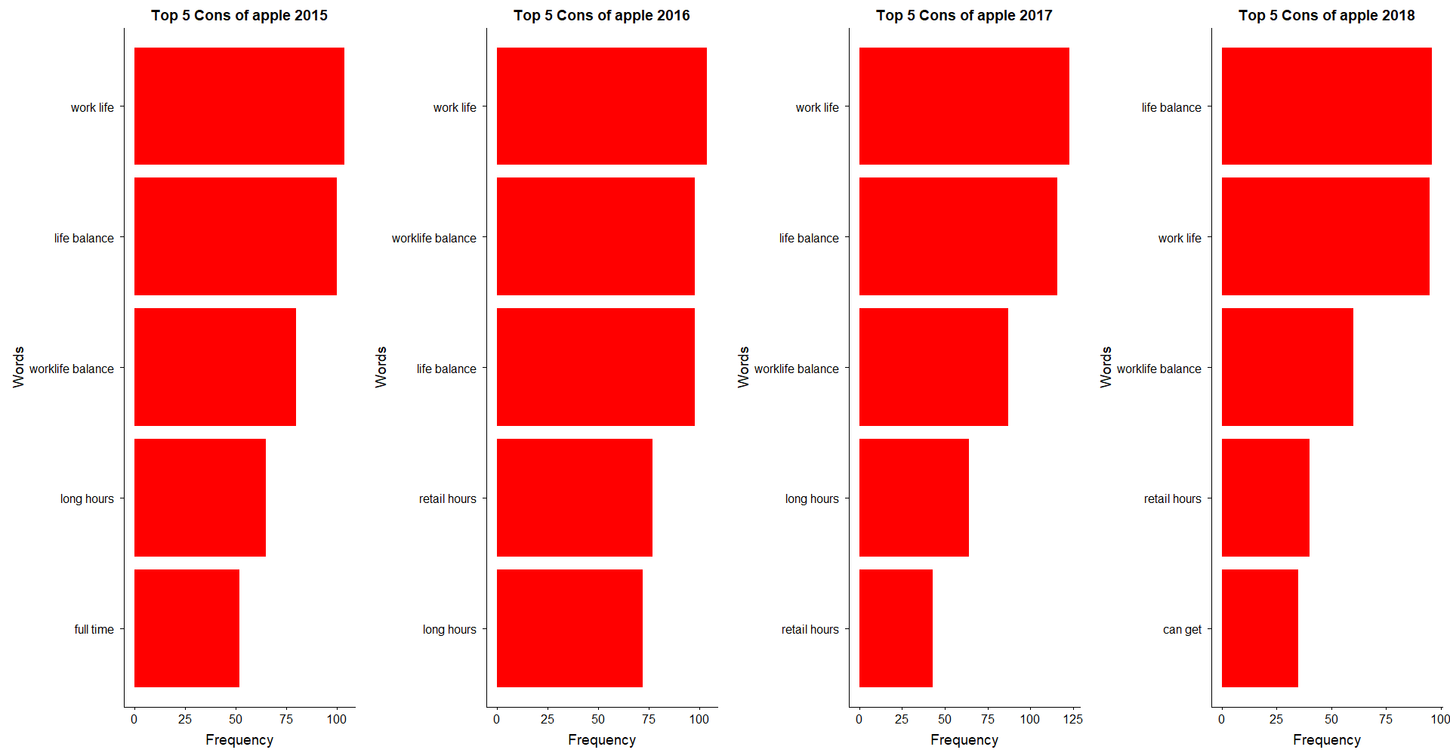

**Step 4: Iteratively Redefining stopwords**

Stop words have been iteratively redefined on the basis of context. This is amongst one of the challenges that we faced during the course of the analysis. This process mostly impacts the cons columns, while the pros remains unchanged.

**Step 5: Drawing Conclusion**



One step closer towards understanding what employee think about their companies! Below relevations can help them identify growing problem within the organization.

**Apple**

**Pros:**

* + Year on Year, Apple seems popular among it’s employee for offering great benefits
  + Work environment and it’s people are also amongst the most talked pros for Apple

**Cons:**

* + Year on Year, long working hours has been troublesome for employee
  + Interestingly, in last couple of years, work environment and upward mobility in the company has been rising issue

**Amazon**

**Pros:**

* + Favored for having the smartest people and work environment with high pay
  + Amazon has focused more on improving work culture and environment, evident by the changing bar plots for year 2018.

**Cons:**

* + Long working hours and mandatory over time seems to be amongst the biggest concerns for people working at Amazon
  + No changes in pattern observed from 2014 - 2018

**Microsoft**

**Pros:**

* + Year on Year, Microsoft seems popular among it’s employee for offering great benefits and good pay
  + Interestingly, people are happy and praise the kind/type of work at Microsoft

**Cons:**

* + Unlike Apple and Amazon, Microsoft is cursed with it’s review system problems and middle management
  + Internal politics and slow growth within organization is a big problem to them

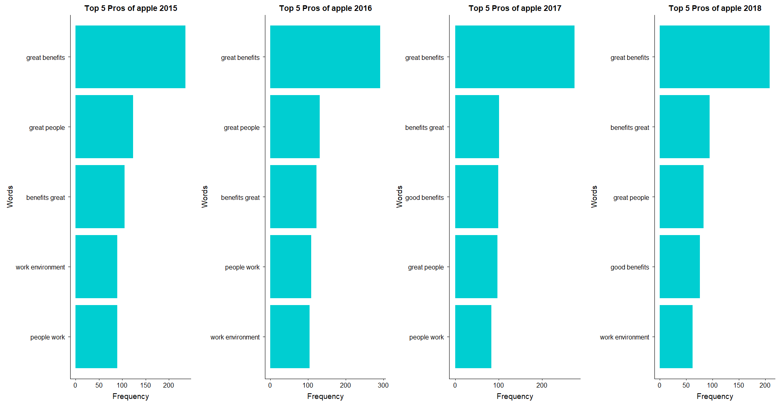

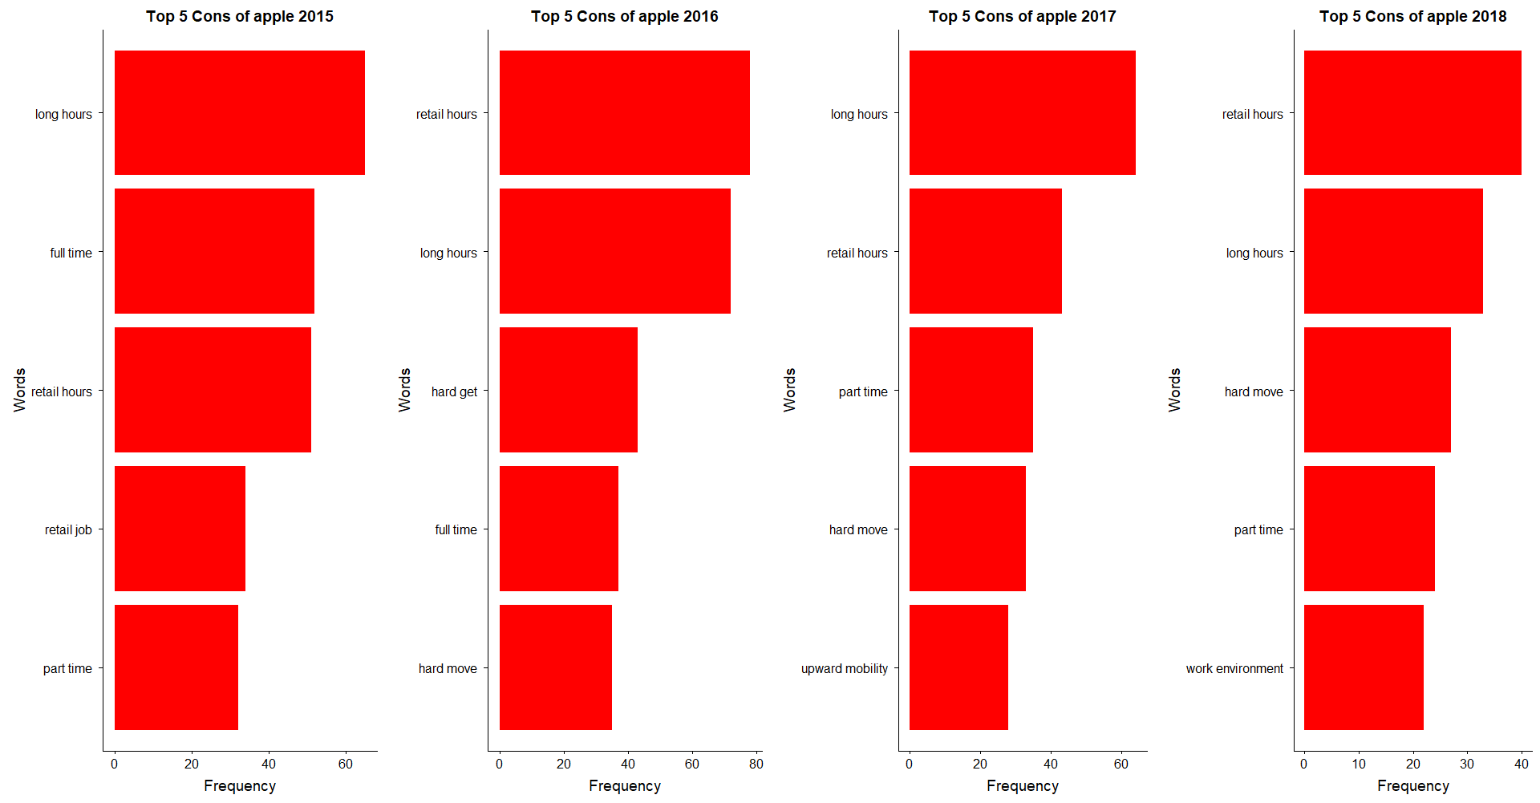

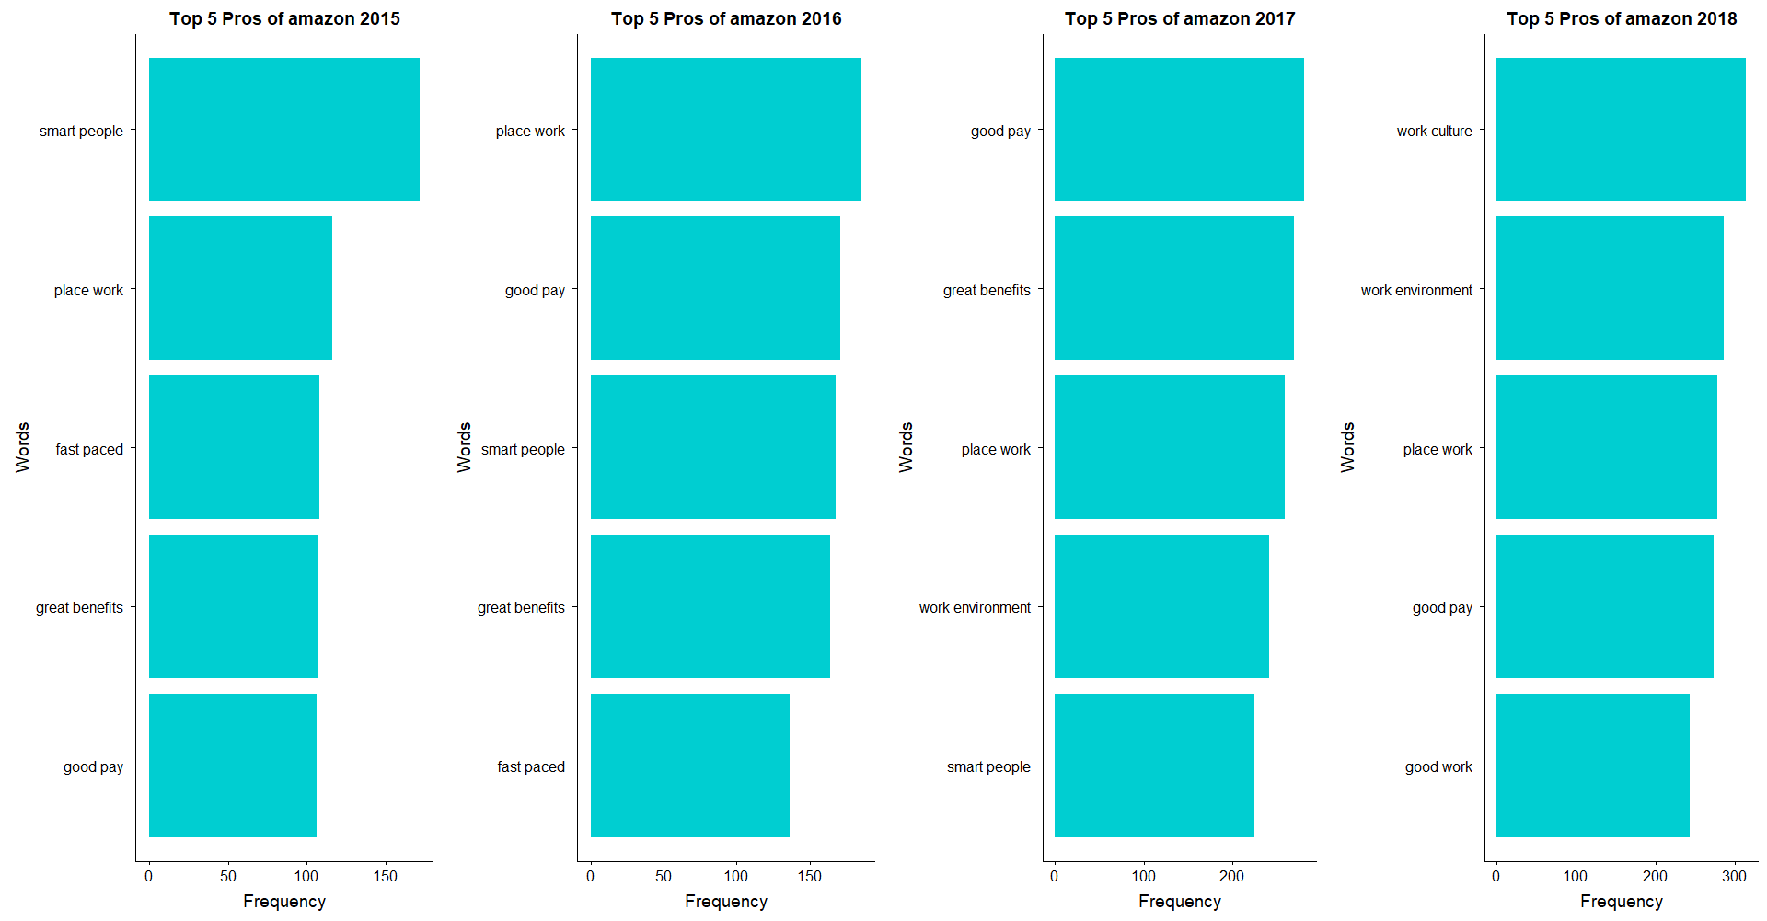

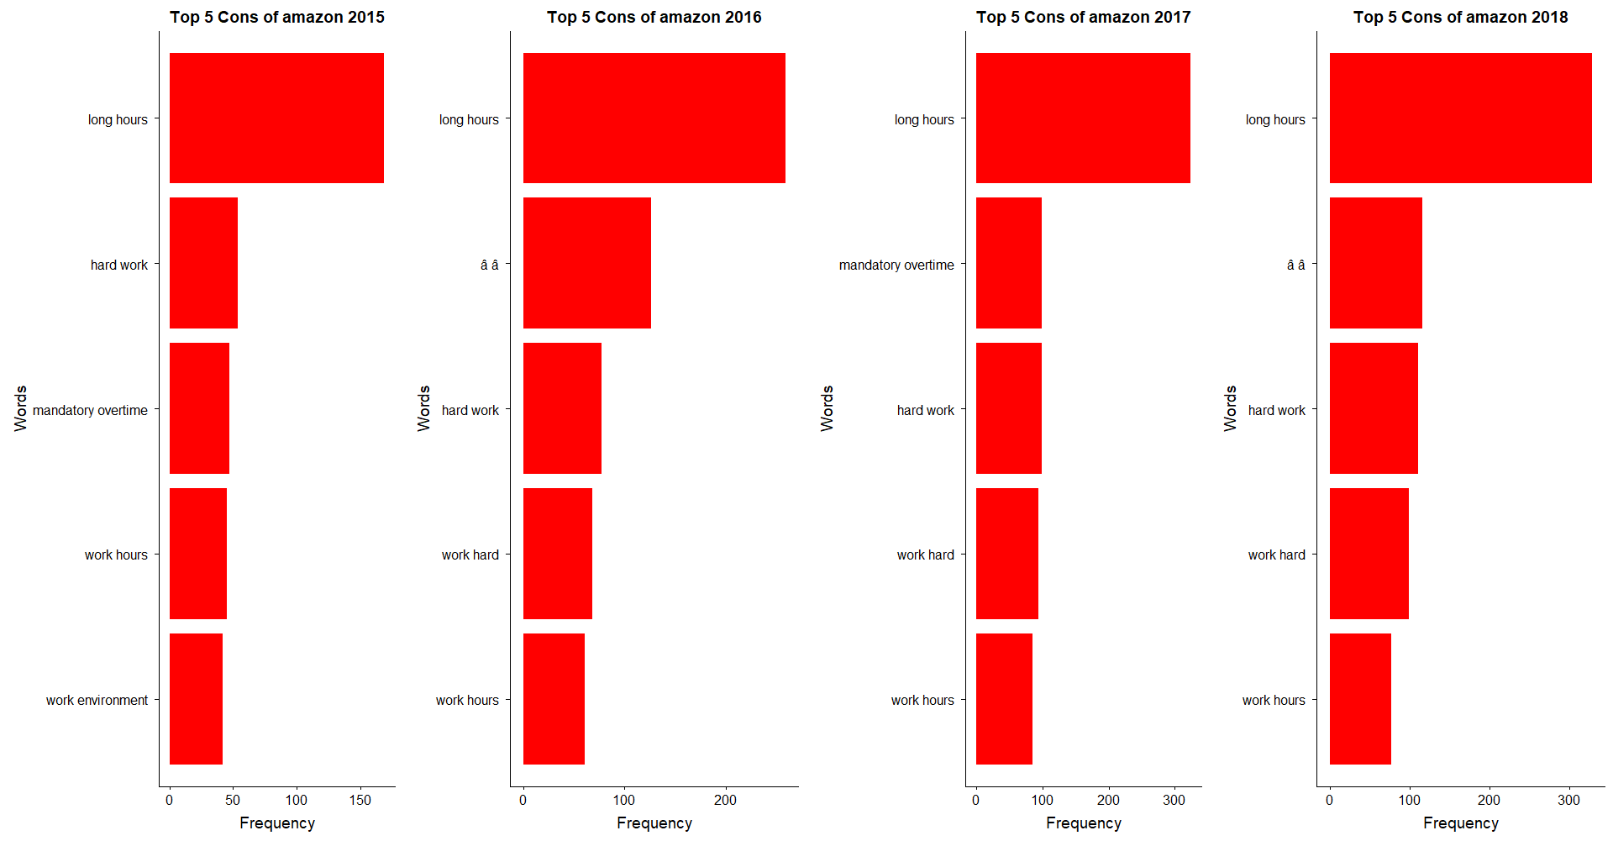

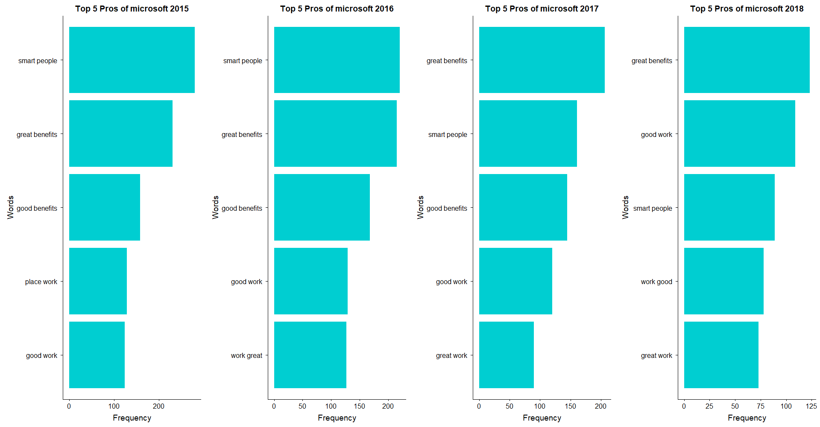

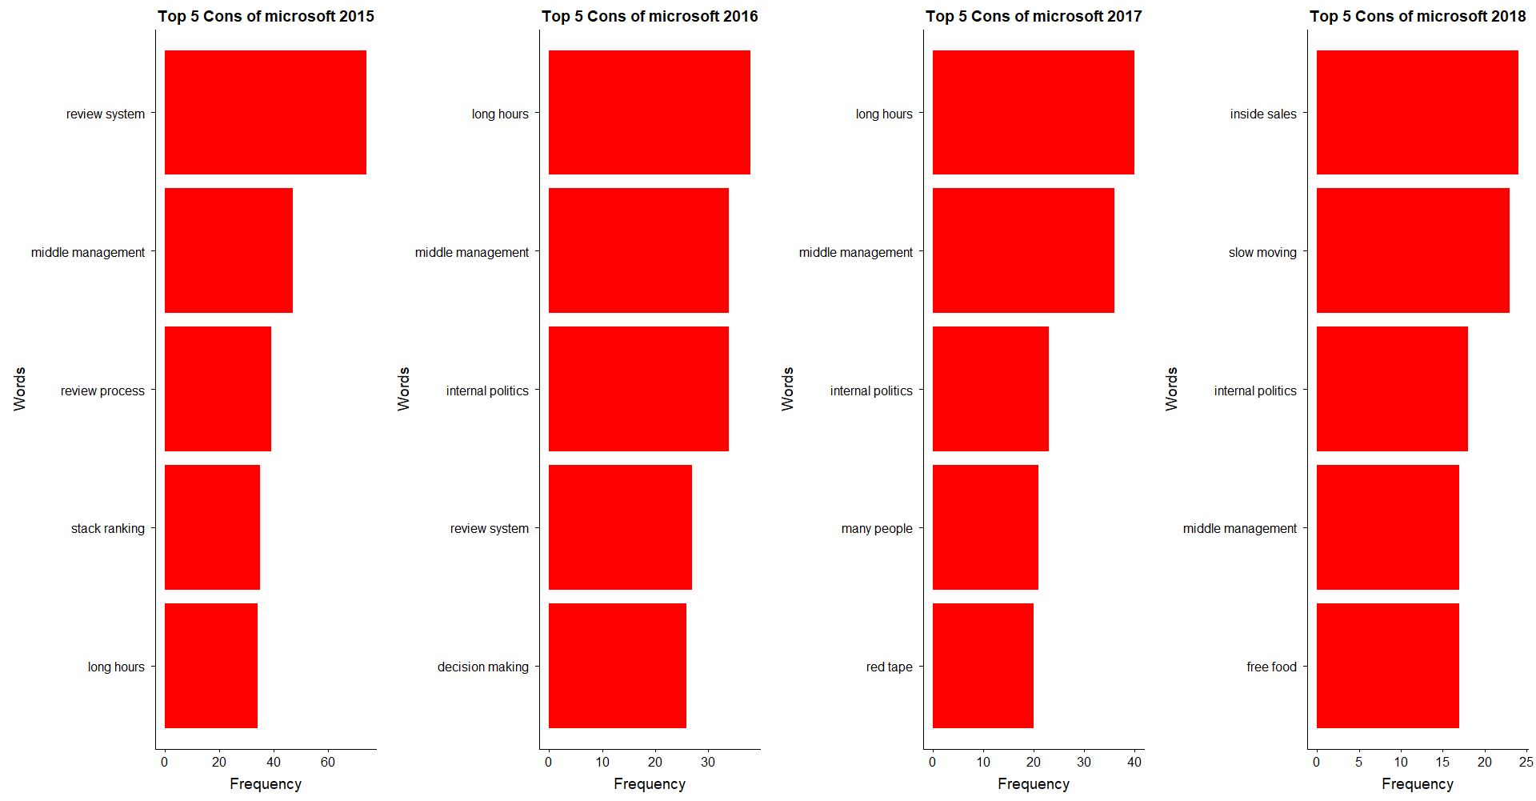

**Sentiment Analysis**

**Most talked about attributes and their effect on ratings**

**PROS:**

A company is rated between 1 to 5. We have tried to understand the most talked about attributes in the description of both the pros and the cons of a company. We then move on to see the extent to which the choice of words describing these attributes affect the ratings.

We divided the ratings as Negative (1-2), Neutral (3) and Positive (4-5). We then found the most commonly occurring unigrams in Pros, after removing stop words. We identified benefits, environment, people and work as the most talked about attributes. Through the below visualization, the patterns in reviews given for these attributes is studied. For each review, we find the words that contribute to positive or negative review for each attribute across rating. These are the words that precede the significant words (benefits, environment, people and work).

We use sentiments from *affinn* lexicon for this analysis. The *affinn* lexicon assigns each word with a score that runs between -5 and 5, with negative scores indicating negative sentiment and positive scores indicating positive sentiment. We have calculated product of score and number of occurrences to identify how much a word affects a review. Top 5 positive and negative words for an attribute across ratings are shown. If multiple words have same effects, all of them are displayed.

For 5 rated companies, reviews have words like great and amazing to describe the staff and service. For 4 rated, good and nice takes their place. The overall score for positive words decreases significantly for Neutral and Negative ratings, as compared to positive ratings.



**CONS:**

We repeated the same process on the Cons column to understand the relevance of words in the negative comments. We found that Management, People, Time and Work are the most talked about negatives.

When we move down the rating, the negative words increase across the attributes. Words like poor, hard and bad dominate the description of attributes of negative reviews. The overall score for these negative words is maximum for Low Ratings and decreases for better ratings.



**Emotions Across Ratings:**

Now that we have found the words that contribute to positive and negative emotions for each attribute across ratings, we will next analyze the general emotion expressed in reviews for each rating. We look at the Summary column for this. NRC lexicon is used for this analysis. The NRC lexicon categorizes words in a binary fashion (“yes”/“no”) into categories of positive, negative, anger, anticipation, disgust, fear, joy, sadness, surprise, and trust. For each star rating, the percentage of words that express the emotions of trust, fear, anger, anticipation, disgust, joy, sadness and surprise are shown below.

A radar plot is made across emotions to show the percentage projected in reviews. Color in this visualization represents the rating of the company whose review is analyzed. We can see that reviews with low rating of 1 and 2 have reviews that predominantly express anger, sadness, fear and disgust. These emotions are expressed the least in high rated reviews. Medium rating of 3 shows a large amount of anticipation and trust in their reviews. High rated restaurants (4 and 5 ratings) express high degrees.

We see that people who give negative ratings predominantly express feelings like fear, disgust and sadness. People who give positive ratings express joy, surprise and trust.

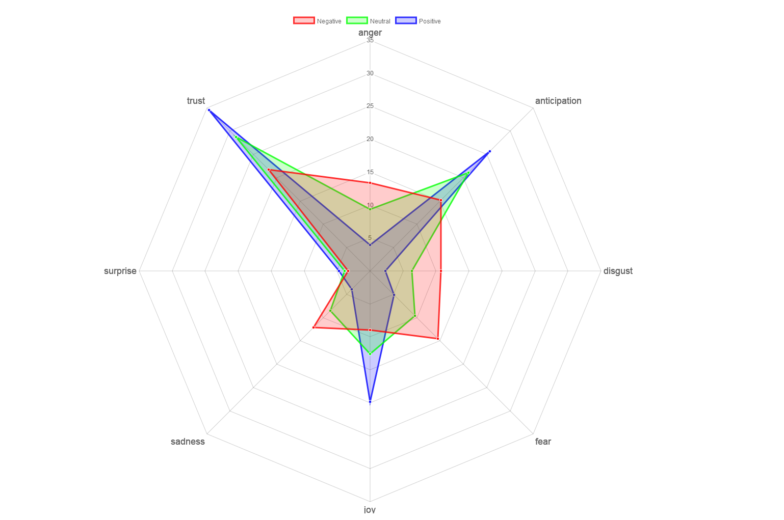

**Conclusion:**

In order to understand the sentiments of employees in pros or positives section of the reviews, four key attributes were identified. The employee’s reaction to benefits, environment, people and work at the companies was analyzed. As initial step, the words commonly used along with the key terms are visually represented in a network chart. To identify the difference between high and low rated reviews, the reviews given to each of these four attributes in each rating category were studied separately. The words that contribute to positive and negative sentiments in each attribute are identified and top 5 positive and negative words were shown in a diverging bar chart. The percentage of different emotions expressed in reviews given to each rating category is shown in a radar chart. The difference in usage of words in reviews given to the three companies Apple, Amazon and Microsoft was also investigated and displayed.